EXT750 MAXI ROLLER
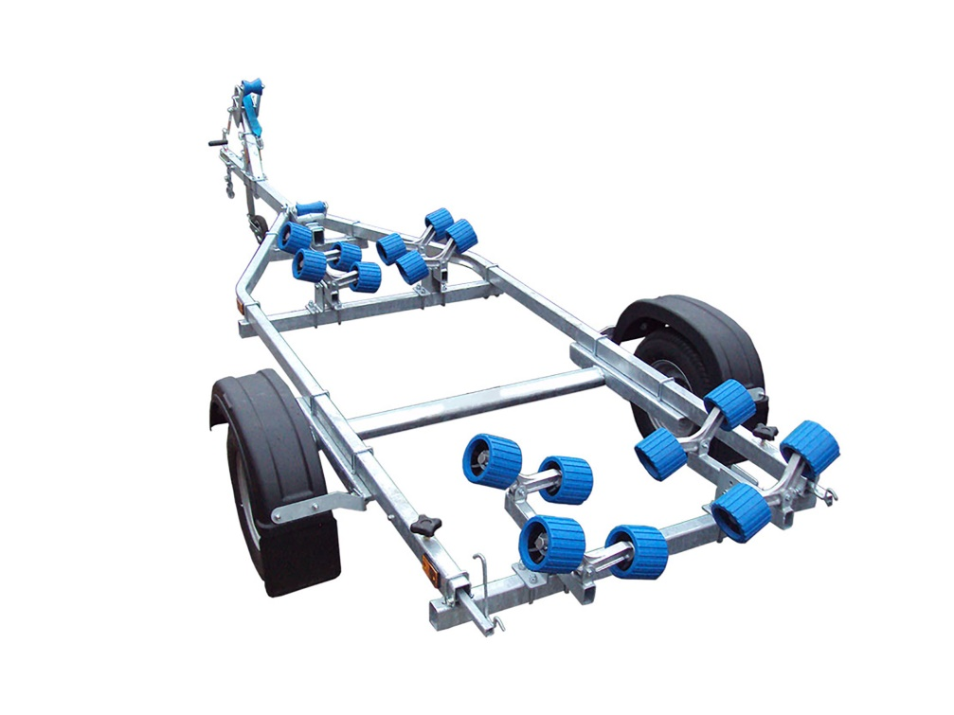
BRAND NEW EXT750 MAXI GALVANISED BOAT TRAILER.

Suitable for dinghies up to 16' (with overhang), 14' hard boats and 5.0m ribs.

With a trailer weight of 145kg it can take a boat weight up to 605kg.

Designed and manufactured in the UK.

Standard features include:

Heavy duty frame
AL-KO axle
Waterproof sealed bearings
16 nylon non marking wobble rollers
Heavy duty keel roller
Height adjustable winch post
10" wheels
48mm jockey wheel
1400lb Dutton Lainson winch
Light board on extendable arms

Everything on this trailer is adjustable, so it can fit most hull shapes.

Overall length: 4.75m

Overall width: 1.57m

RRP: £1065

