EXT750 MAXI BUNK

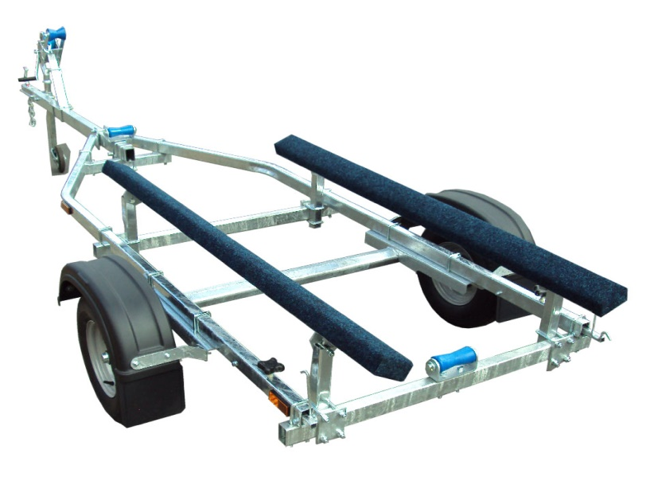

THE ALL NEW AND IMPROVED EXT750 MAXI BUNK GALVANISED BOAT TRAILER.

Suitable for dinghies up to 16' (with overhang), 14' hard boats and 5m ribs.

With a trailer weight of 145kg it can take a boat weight up to 605kg.

Designed and manufactured in the UK.

Standard features include:

Heavy duty frame
AL-KO axle
Waterproof sealed bearings
Pair of 1.8m carpeted bunks
Heavy duty keel rollers
Height adjustable winch post
10" wheels
42mm jockey wheel
1400lb Dutton Lainson winch
Light board on extendable bars

Everything on this trailer is adjustable, so it can fit most hull shapes.

Overall length: 4.70m

Overall width: 1.55m

RRP: £1065

