EXT750 COMPACT SWING

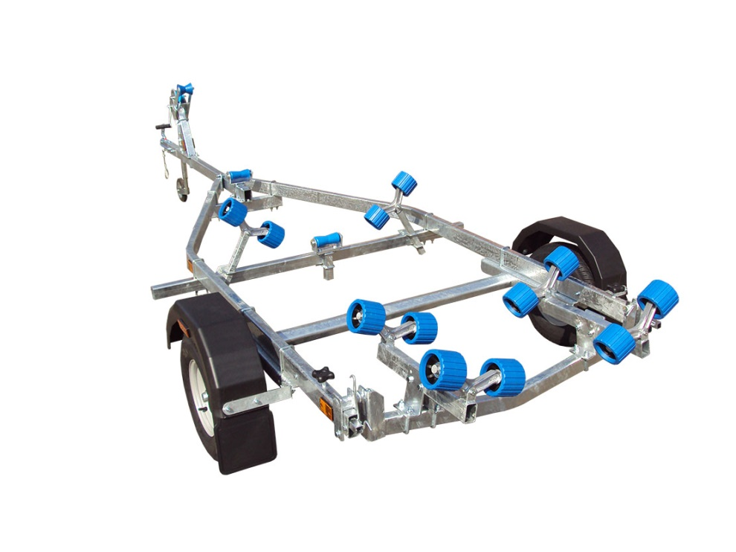
BRAND NEW EXT750 COMPACT SWING GALVANISED BOAT TRAILER.

Suitable for hard boats up to 14', and 5m ribs.

With a trailer weight of 170kg it can take a boat weight up to 580kg

Designed and manufactured in the UK.

Standard features include:

Heavy duty frame
AL-KO axle
Waterproof sealed bearings
Adjustable swinging arm
12 nylon non marking wobble rollers
2 heavy duty keel rollers
Heavy duty height adjustable winch post
10" wheels
42mm jockey wheel
1400lb Dutton Lainson winch
Light board on extendable bars

Everything on this trailer is adjustable, so it can fit most hull shapes.

Overall length: 4.75m

Overall width: 1.85m

RRP: £1384

