EXT500 SUPER ROLLER
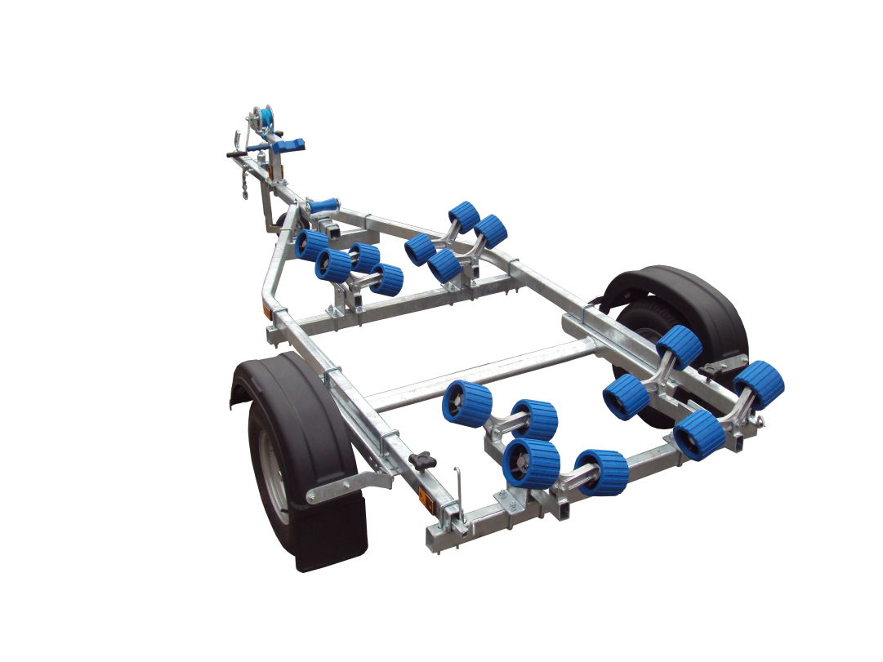
BRAND NEW EXT500 SUPER ROLLER GALVANISED BOAT TRAILER.

Suitable for dinghies up to 15' (with overhang), 12' hard boats and 4.3m ribs.

With a trailer weight of 125kg it can take a boat weight up to 375kg.

Designed and manufactured in the UK.

Standard features include:

Heavy duty frame
AL-KO axle
Waterproof sealed bearings
16 nylon non marking wobble rollers
Height adjustable keel roller
Fixed height winch post
10" wheels
48mm jockey wheel
900lb Dutton Lainson winch
Light board on extendable bars

Everything on this trailer is adjustable, so it can fit most hull shapes.

Overall length: 4.20m

Overall width: 1.55m

RRP: £959

