EXT500 BUNK
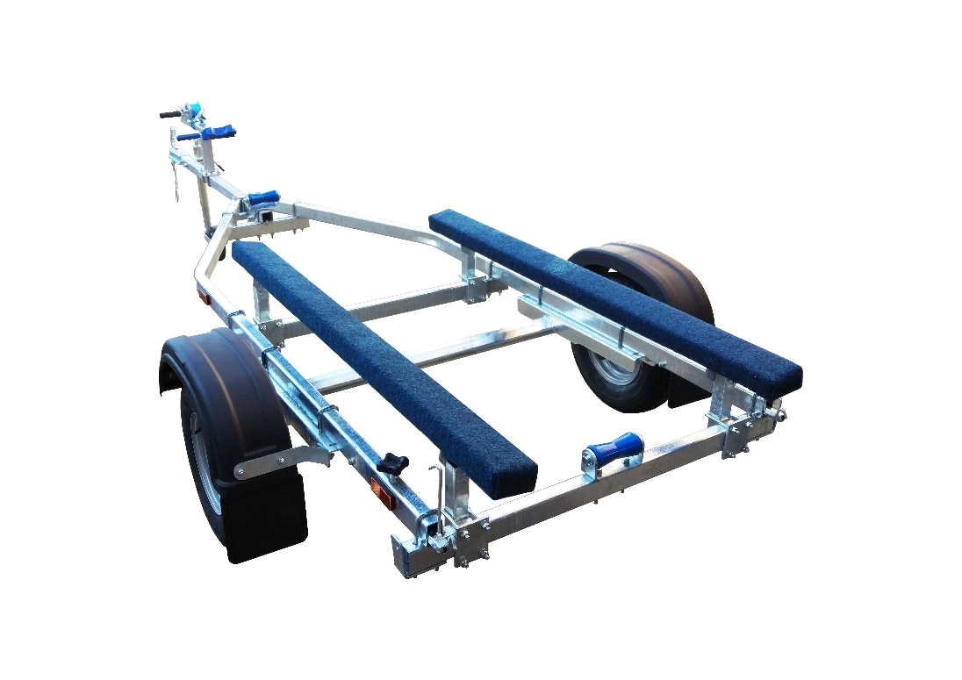

BRAND NEW EXT500 BUNK GALVANISED BOAT TRAILER.

Suitable for dinghies up to 15'(with overhang), 12' hard boats and 4.3m ribs.

With a trailer weight of 125kg it can take a boat weight up to 375kg.

Designed and manufactured in the UK.

Standard features include:

Heavy duty frame
AL-KO axle
Waterproof sealed bearings
1.6m bunks
Heavy duty keel rollers
Fixed height winch post
10" wheels
48mm jockey wheel
900lb Dutton Lainson winch
Light board on extendable bars

Overall length: 4.20m

Overall width: 1.55m

RRP: £959

