EXT3500 SUPER ROLLER

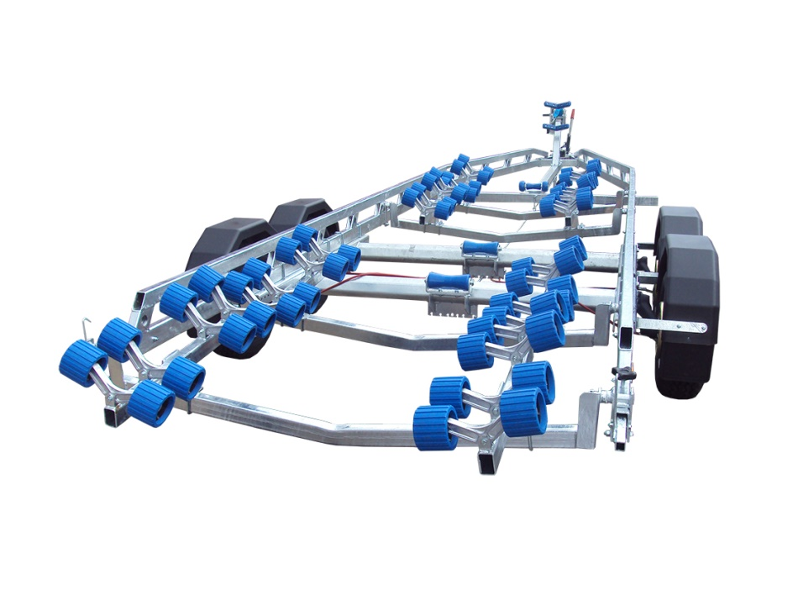

BRAND NEW EXT3500 SUPER ROLLER GALVANISED BOAT TRAILER.

Suitable for hard boats up to 24' and 7.8m ribs.

With a weight of 650kg it can take a boat weight up to 2850kg.

Designed and manufactured in the UK.

Standard features include:

Heavy duty double ladder frame
2 AL-KO 1900kg axles
AL-KO coupling with lockable hitch
4 adjustable swinging arms
64 nylon non marking wobble rollers
3 heavy duty keel rollers
Heavy duty height adjustable winch post
185R13C wheels
Serrated jockey wheel
2500lb Dutton Lainson winch
Light board on extendable bars

Everything on this trailer is adjustable, so it can fit most hull shapes.

Overall length: 8.00m

Overall width: 2.37m

RRP: £5091

