EXT350 BUNK
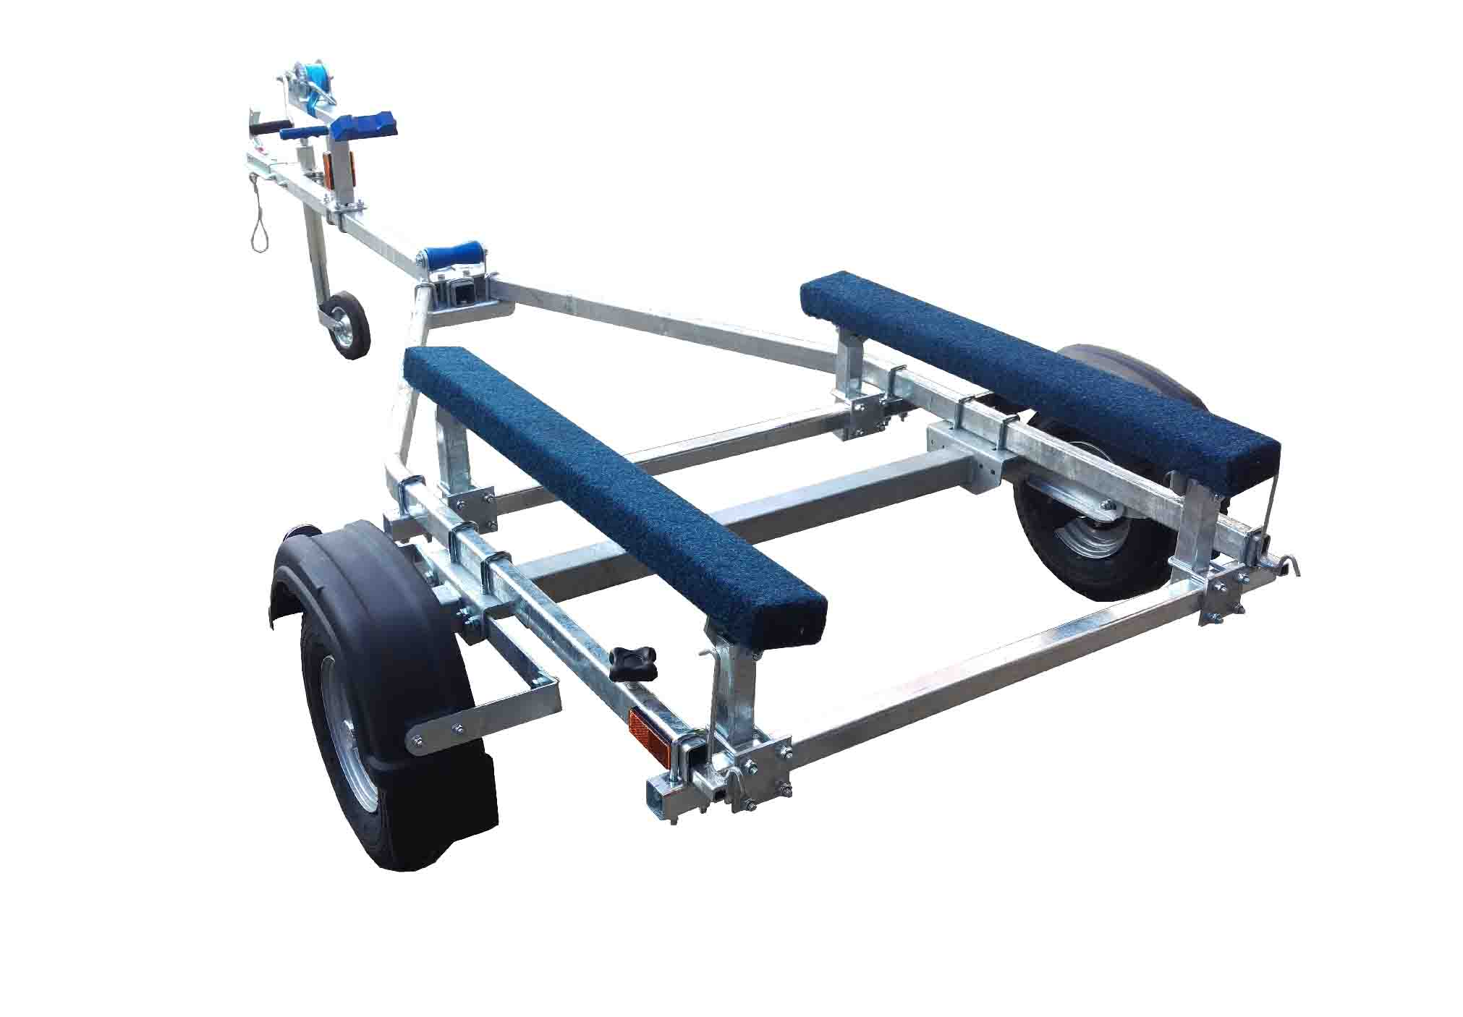

BRAND NEW EXT350 BUNK GALVANISED BOAT TRAILER.

Suitable for dinghies up to 12'(with overhang), 10' hard boats and 3.5m ribs.

With a trailer weight of 95kg it can take a boat weight up to 255kg.

Designed and manufactured in the UK.

Standard features include:

Light weight frame
AL-KO axle
Waterproof sealed bearings
1m bunks
Heavy duty keel roller
Fixed height winch post
8" wheels
48mm jockey wheel
900lb Dutton Lainson winch
Light board on extendable bars

Overall length: 3.44m

Overall width: 1.55m

RRP: £788

