EXT3000 SUPER ROLLER

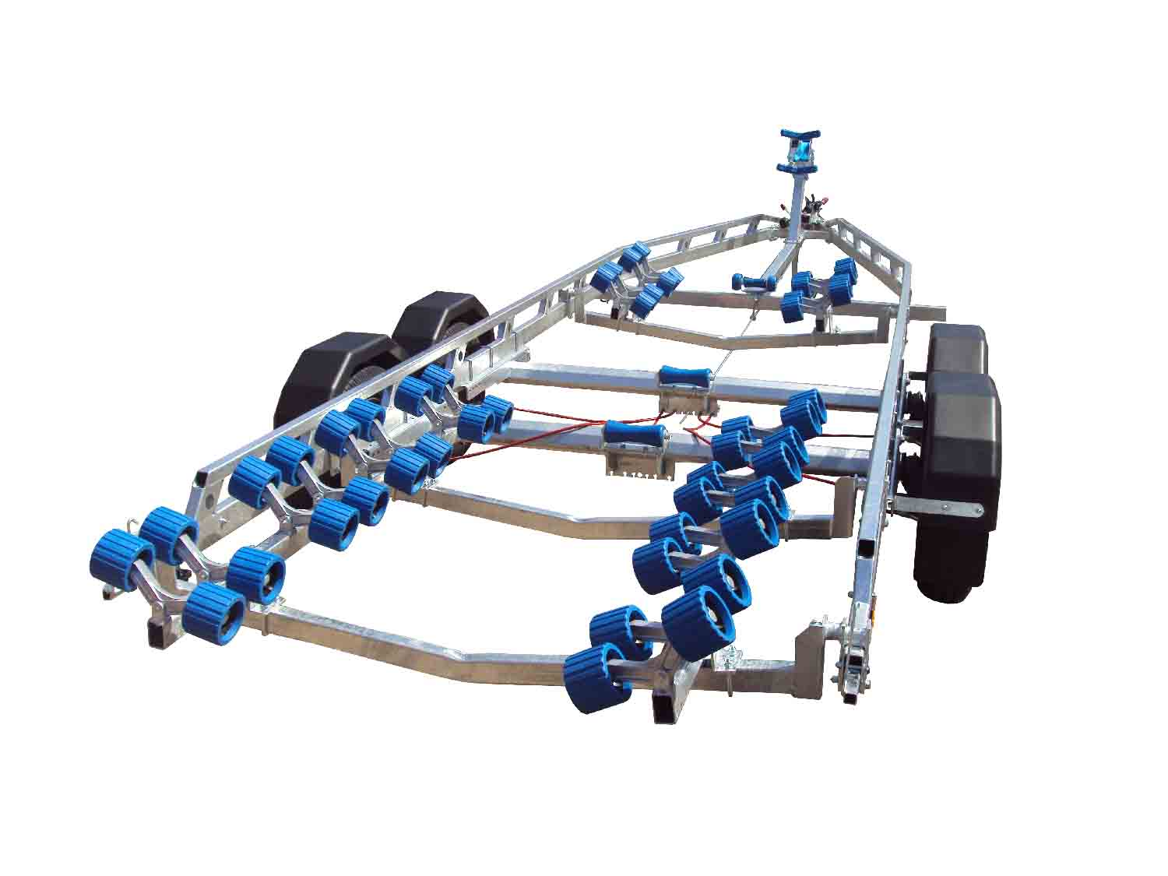

BRAND NEW EXT3000 SUPER ROLLER GALVANISED BOAT TRAILER.

Suitable for hard boats up to 24' and 7.8m ribs.

With a trailer weight of 550kg it can take 2450kg of boat weight.

Designed and manufactured in the UK.

Standard features include:

Heavy duty double ladder frame
2 AL-KO axles with
Waterproof sealed bearings
AL-KO coupling with lockable hitch
3 adjustable swinging arms
52 nylon non marking wobble rollers
3 Heavy duty keel roller
Heavy duty height adjustable winch post
175R13 wheels
48mm Serrated jockey wheel
2500lb Dutton Lainson winch
Light board on extendable bars

Everything on this trailer is adjustable, so it can fit most hull shapes.

Overall length: 8.00m

Overall width: 2.37m

RRP: £4719

