EXT2400 SUPER ROLLER
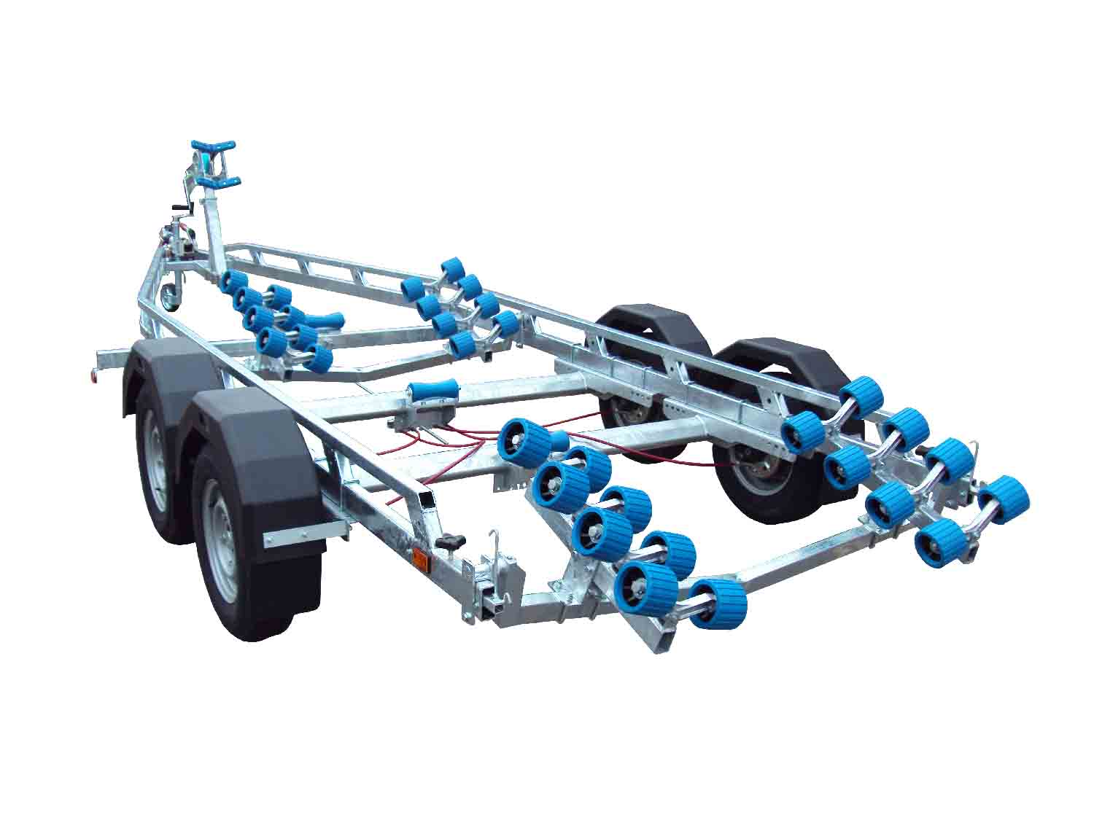

BRAND NEW EXT2400 SUPER ROLLER GALVANISED BOAT TRAILER.

Suitable for hard boats up to 21’ and 7m ribs

With a trailer weight of 550kg it can take a boat weight up to 1850kg.

Designed and manufactured in the UK.

Standard features include:

Heavy duty frame double ladder
AL-KO axles
Waterproof sealed bearings
AL-KO coupling with lockable hitch
32 nylon non marking wobble rollers
3 keel rollers
2 swinging arms
Heavy duty height adjustable winch post
165R13C wheels
48mm serrated jockey wheel
2500lb Dutton Lainson winch
Light board on extendable bars.

Everything on this trailer is adjustable, so it can fit most hull shapes.

Overall length: 7.00m

Overall width: 2.37m

RRP: £3933

