EXT1500 SUPER ROLLER

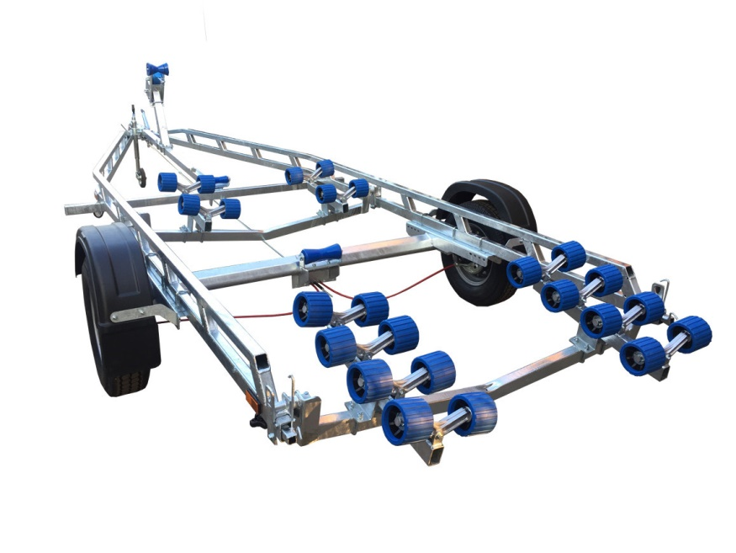
BRAND NEW EXT1500 SUPER ROLLER GALVANISED ROLLER TRAILER.

Suitable for dinghies up to 22’ (with overhang), 20’ hard boats and 6.5 ribs

With a trailer weight of 350kg it can take 1150kg of boat weight

Designed and manufactured in the UK

Standard features include:

Heavy duty double ladder frame
AL-KO axle
Waterproof sealed bearings.
2 adjustable swinging arms
24 nylon non marking wobble rollers
2 heavy duty keel roller
Heavy duty height adjustable winch post
175R13 wheels
42mm jockey wheel
2000lb Dutton Lainson winch
Light board on extendable arms

Everything on this trailer is adjustable, so it can fit most hull shapes.

Overall length: 6.55m

Overall width: 2.20m

RRP: £2984

