EXT1300 SUPER ROLLER

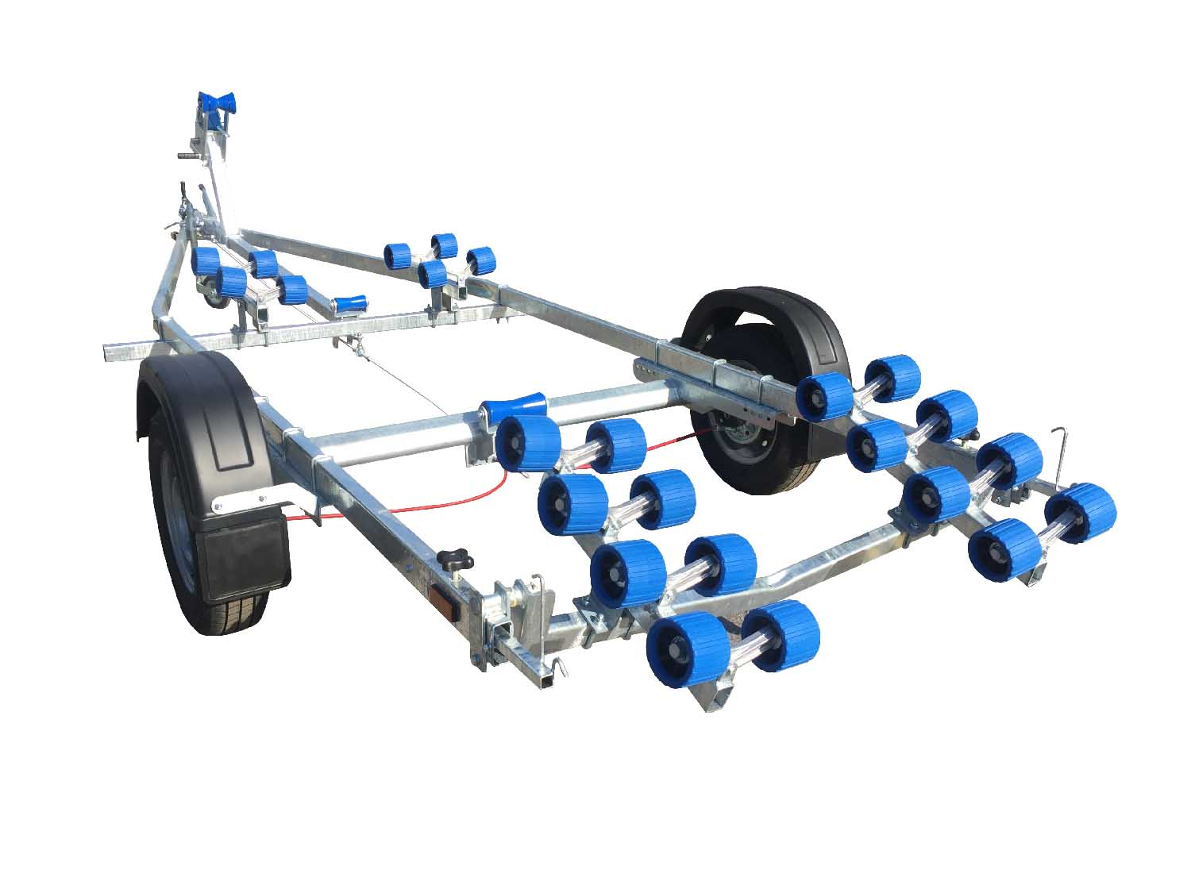
BRAND NEW EXT1300 SUPER ROLLER GALVANISED BOAT TRAILER.

Suitable for dinghies up to 20’ (with overhang), 17’ hard boats and 5.6m ribs

With a trailer weight of 300kg it can take 1000kg of boat weight.

Designed and manufactured in the UK

Standard features include:

Heavy duty frame
AL-KO axle
Waterproof sealed bearings
Adjustable swinging arm
24 nylon non marking wobble rollers
2 heavy duty keel rollers
Heavy duty height adjustable winch post
165R13 wheels
42mm jockey wheel
2000lb Dutton Lainson winch
Light board on extendable bars

Everything on this trailer is adjustable, so it can fit most hull shapes.

Overall length: 5.70m

Overall width: 2.05m

RRP: £2463

